**JavaScript Basics**

1. **JavaScript:** Scripts can be executed in the body, head, or from external.   
   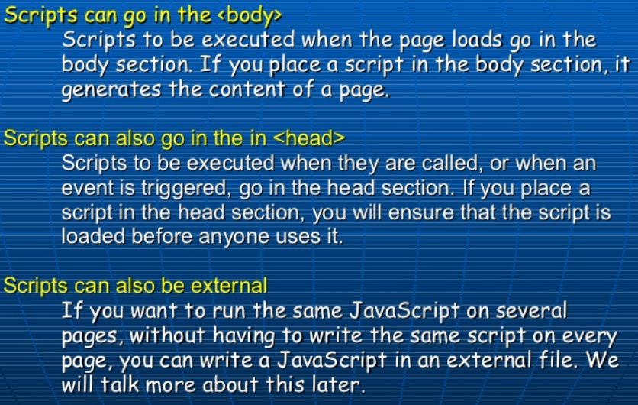

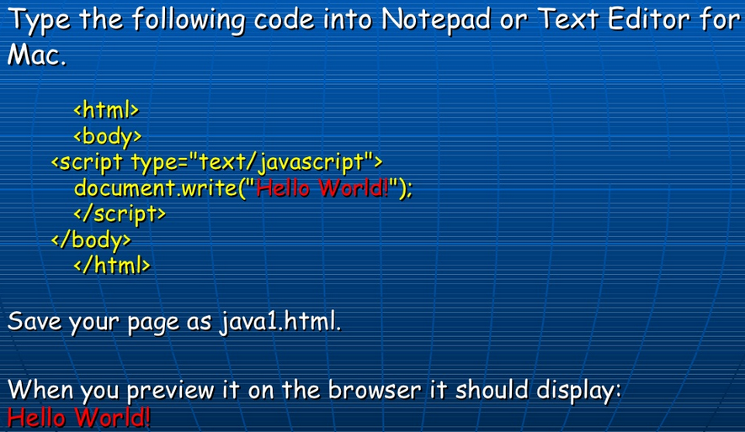

In this case the type of script is text. <script type=”text/javascript”>

It tell the browser to write “Hello World” on the page

1. **JavaScript can do:**

* JavaScript can react to events
* JavaScript can read and write HTML elements.
* JavaScript can be used to validate data
* JavaScript can be used to detect the visitor’s browser
* JavaScript can be used to create cookies.

<http://www.slideshare.net/fantasticdigitaltools/introduction-to-java-scripting>

1. **JavaScript Syntax & Rule:**

* It is case sensitive. (Statements, create/call variables, objects and functions)
* Semicolon **;** is used at the end of each executable statement.

Ex: document.write(“Hello Sumi”);

* Using semicolons makes it possible to write multiple statements on one line.

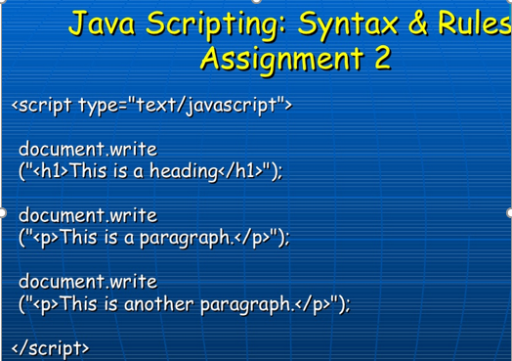

* JavaScripts statements can be grouped together in blocks.
* Blocks starts with a left curly bracket { and ends with a right curly bracket }
* The purpose if a block is to make the sequence of satements execute together.

1. **JavaScript** variables can be used to hold values (x=5) or expressions (z=x+y).   
   **Variable** name must begin with lowercase letter such as **totalAll**.  
   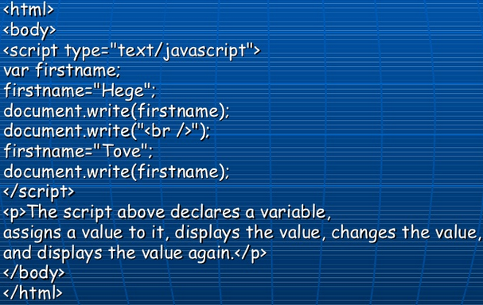
2. **JavaScript conditional statements:** It is require to perform different decisions.

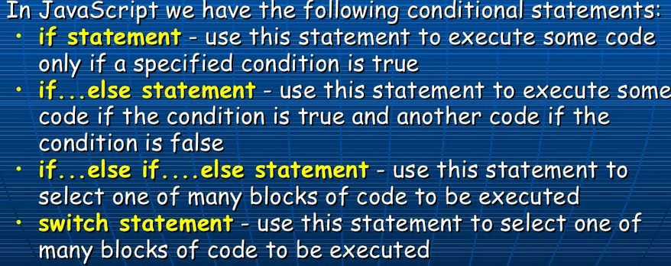

**if(condition)  
{  
code to be executed if condition is true;  
}**

**Else  
{  
code to be executed if condition is not true;  
}**

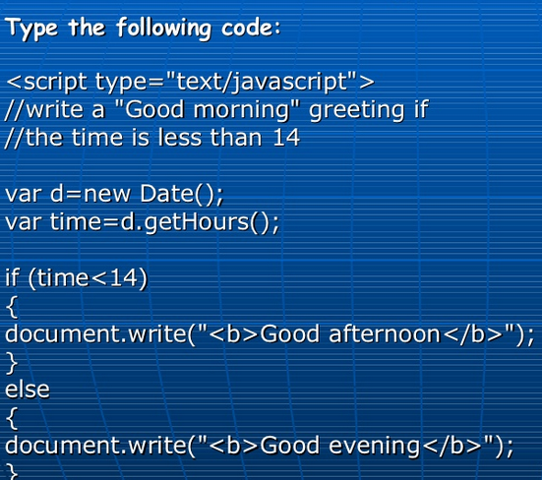

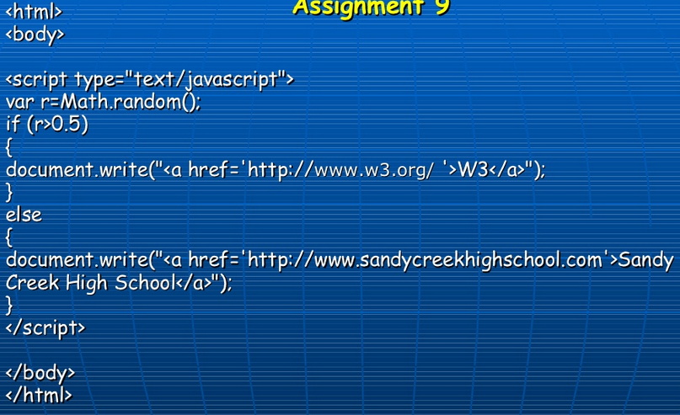

1. **JavaScript** has **7 types:   
   Number, String, prompt(), Alert(), If Else Comparison operators, Functions,**

**Ex**: var name = prompt(‘what is your name’); var lastName= prompt(‘What is you last name’); alert(name + ‘ ’ + last name);

